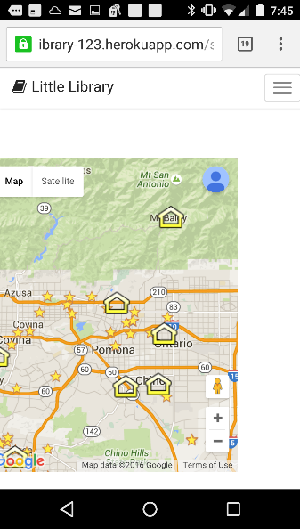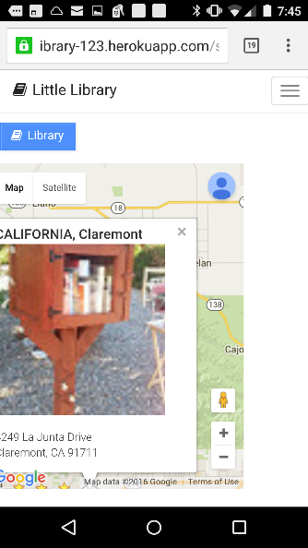

**Books**

The Martian by Andy Weir

All I Need to Know I Learned from My Cat by Suzy Becker

Parlor Cats by Cynthia Hart and John Grossman

A cat is watching by Roger A. Caras

Why Cats Do That by Karen Anderson

Mitten/kitten by Jerome Martin

The Tribe of Tiger by Elizabeth Marshall Thomas

ISBN Bar Code Scanner

ISBN, or title and author(s) …

**Books**

**Check In**

**Check Out**

□ The Martian by Andy Weir

□ All I Need to Know I Learned from My Cat by Suzy Becker

□ Parlor Cats by Cynthia Hart and John Grossman

□ A cat is watching by Roger A. Caras

□ Why Cats Do That by Karen Anderson

□ Mitten/kitten by Jerome Martin

□ The Tribe of Tiger by Elizabeth Marshall Thomas

Title: The Martian

Author: Andy Weir

Publisher: Broadway Books,

Published Date: 2015-08-18

ISBN 13: 9781101905005

Pages: 448

Genre: Fiction

Google Avg. Rating: 4.0



***** 5 Reviews